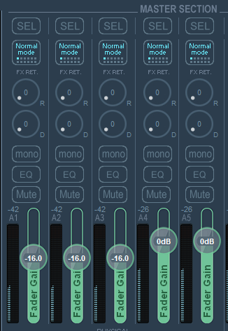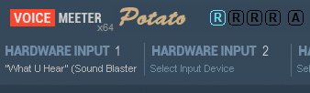

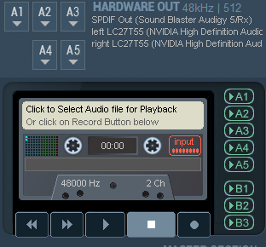

These are the three audio volume controls.

Use the fader gain to see which one’s on, then realign all using the volume control.

Select “Speakers (Sound Blaster Audigy 5/Rx)” in Windows sound settings:

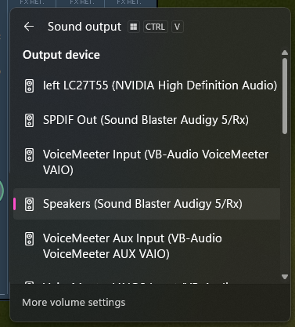

Using the external app “Voicemeeter Windows Volume” app, bind Win vol ctrl to all three outputs:

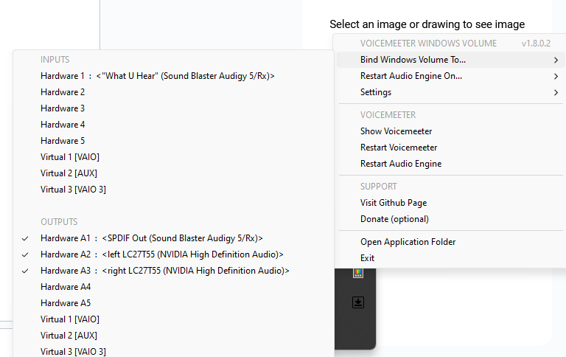

More Windows volume settings:

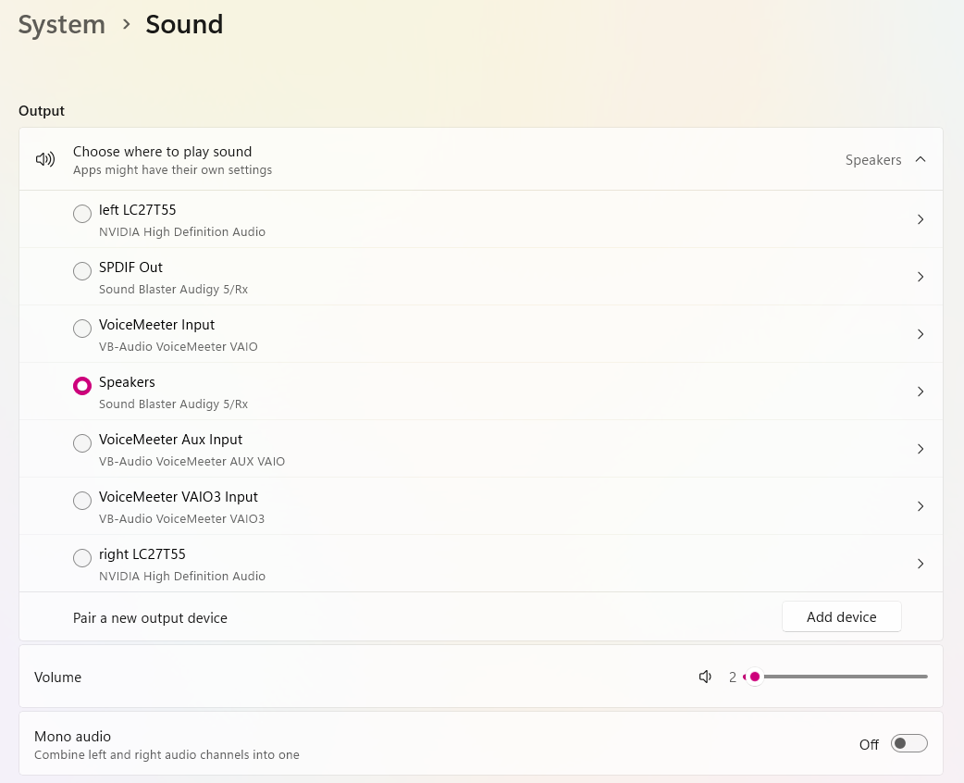

Individual speaker settings:

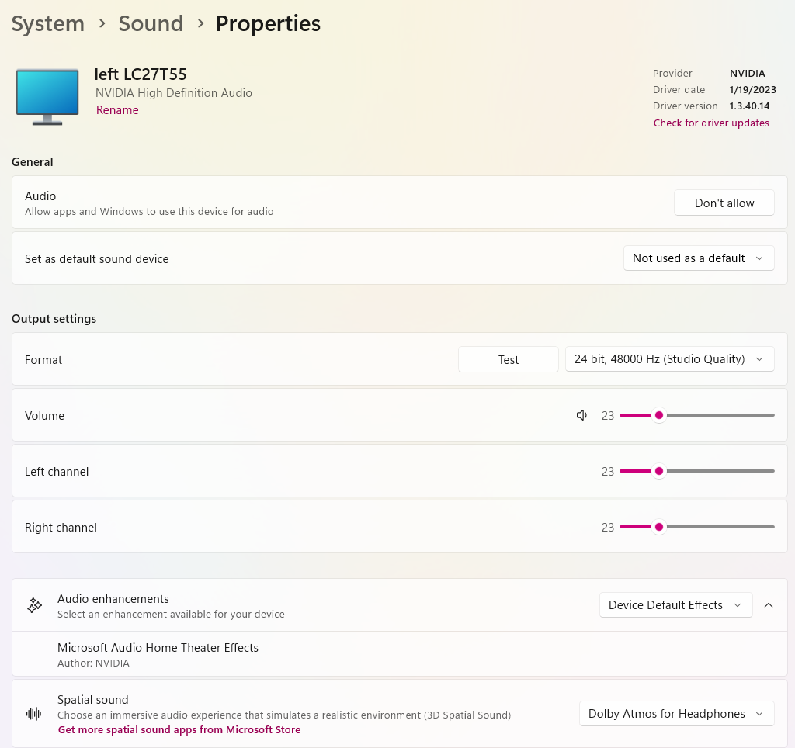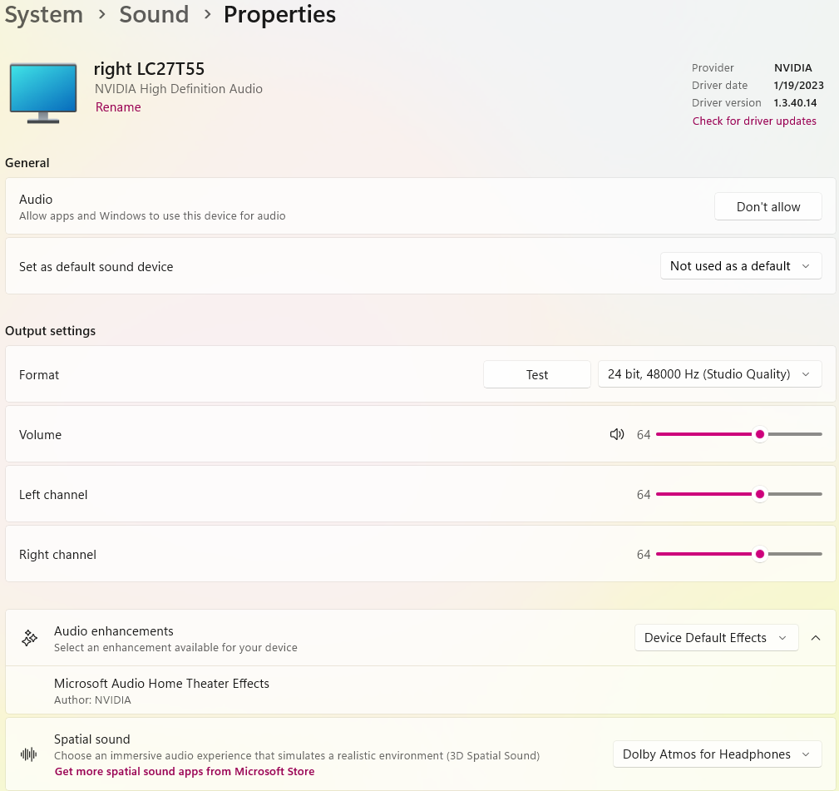

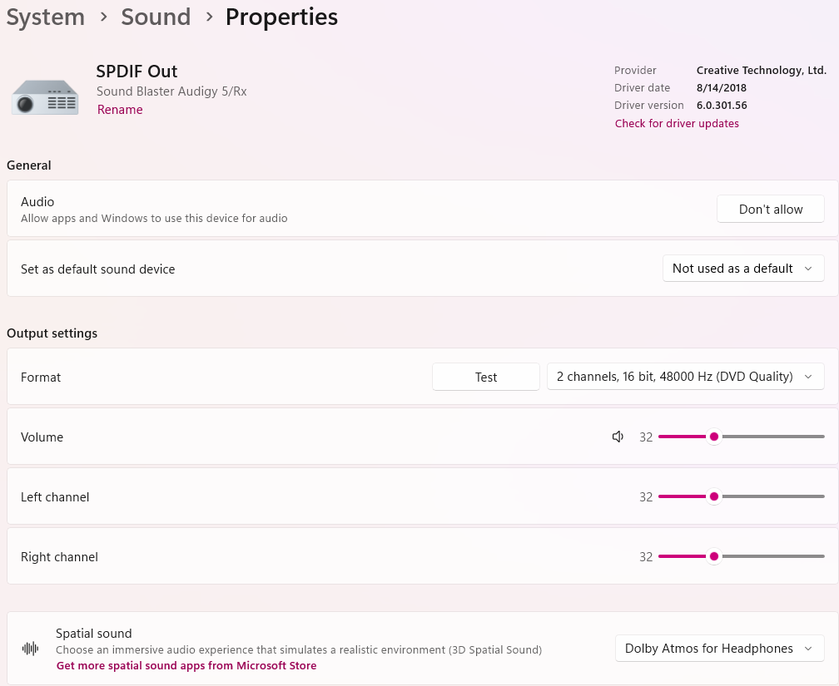

When in doubt, uninstall the drivers for the monitors and check for changes, reinstall:

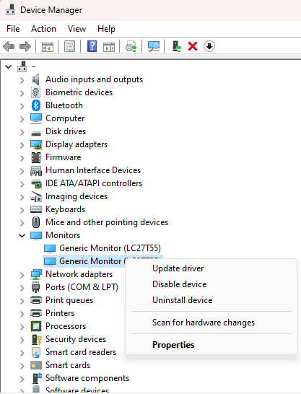

You can also use the external application to restart the audio engine or Voicemeeter itself.

